**LAB - 6**

**Name: Abdul Ghaffar Kalhoro (194699)**

**&**

**Ahmad Amjad Mughal (121672)**

**BSCS-6C**

**Task:1,2,3:**

In this task we have to Remove C style multi line comments (/* Multiline Comments */) and single line comments (//single line comments):-

In sources File run task2_3.l using flex with input1.c as input argument.

**Output:**

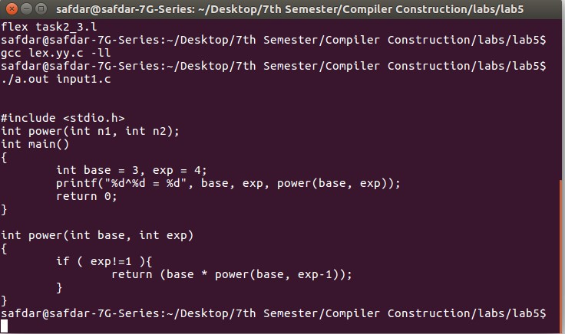

**Task 4:**

In this task we had to implement lexer for C language with various Regular Expression.

In sources File run task4.l using flex with input2.c as input argument as shown in output.

**Output:**

